**EXECUTION STEPS**

1. Install Python (version: 3.6.5 ) from the link below:

<https://www.python.org/downloads/>

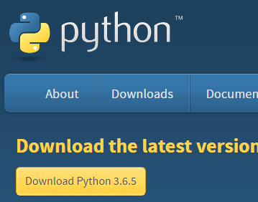

Steps for installing Python :-

* Download and Run the Installer.
* On the first screen, enable the “ADD Python 3.6 to PATH “ optiona dn then click on “Install Now”

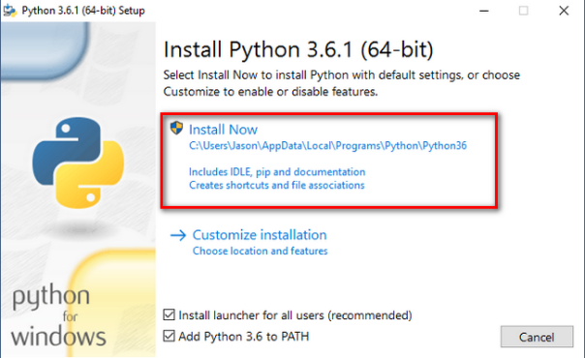

* Next, click on the “Disable path length limit” option . This removes the limitation on the MAX_PATH variable and click on close to finish the installation.

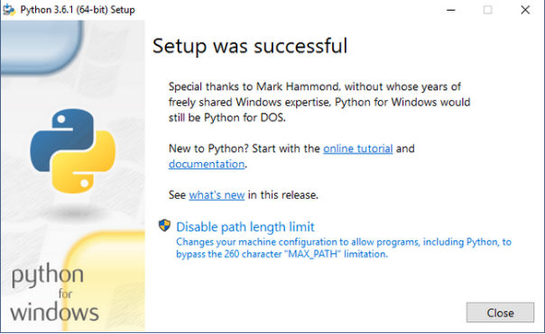

1. Copy the below scripts to the python directory **C:/Python 27**



anonymous.py: This is the script to be executed to anonymize the source data files.

shared_code.py: This module will not be used individually. It is a common code container.

1. Create a folder “source” in the D:\ [ DATA(D:) ] folder. And copy the source files to that directory in the .csv format.

NOTE: The Source folder should be named in **lowercase** only.

Example:-

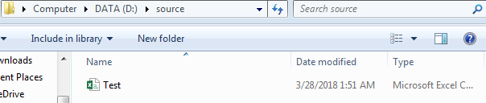

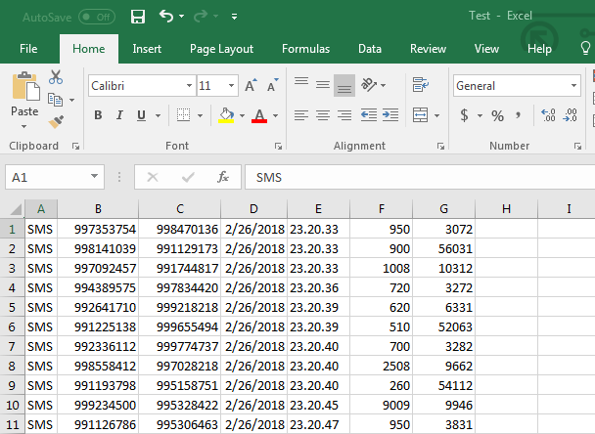

1. Navigate to the path where the scripts are placed (cd **C:/Python 27 )** and execute the script via command line (cmd prompt) using the below command :-



The target folder and mapping folders get created in D disk .

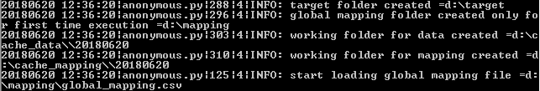

Verify the successful execution of the script.

Once the script is executed, it display a message “data generator unit testing finished” as in the screen shot below. This denotes the successful completion of anonymization.



The target folder, mapping folder gets created in the D disk in your computer:

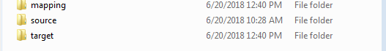

1. After the successful completion of the script, you may find the anonymized file created under the Target folder in DATA(D:) Drive and the global_mapping doc in the mapping folder.

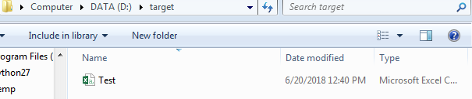

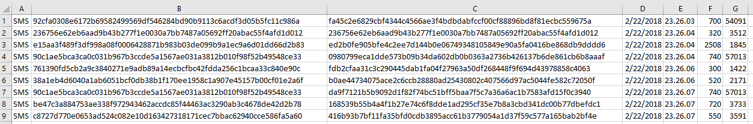

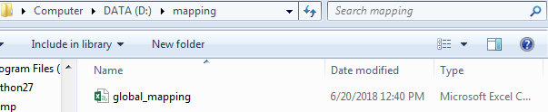

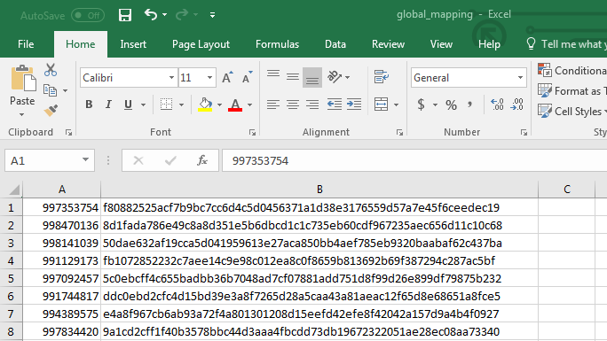

1. You may then rename the Target folder and execute the next set of files which needs to be anonymized by copying them to the Source folder and re-executing the script.

**NOTE:** Do not delete the global_mapping document created in the mapping directory.